Inspired by Josef’s Figma Concept here: <https://www.figma.com/file/Wbr92wkrSLLVY3u5EHwft4/Ricochet?node-id=111%3A902>

LucidChart behind screenshots here:

<https://lucid.app/lucidchart/e3f548ce-0772-494a-875b-8417786aa3ef/edit?invitationId=inv_ace9923d-ab2e-4ebc-8de0-421673dacd8a>

1. User selects an input token *and then* an output token. This may be done via modal. Order is important because based off of input token selected, then output token list will be generated.
   1. Ex: If input token is DAI, then Output token list cannot contain IDLE because we don’t support DAI>IDLE

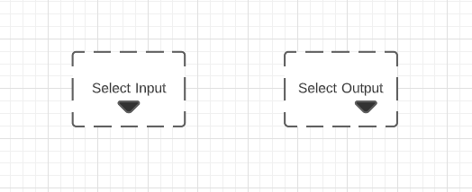

1. Once Input and Output options have been selected, user may drag a line from the input token box to the output token box.
   1. After that line is dragged and connected, the user may select a rate and start the flow transaction.
   2. Another Select Output box appears in a column to the right. The only way a user can start a WETH stream now is by selecting an output token in that box and dragging a line to it.

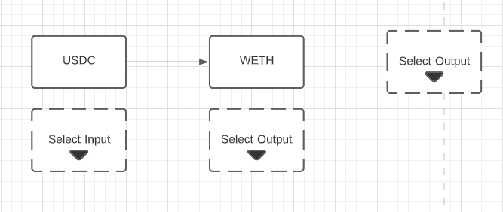

1. Here’s an example viz of a user opening a second USDC stream to another rexMarket

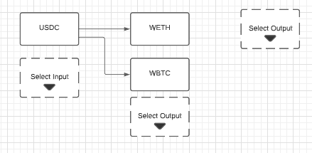

1. The only way a user can start a WETH stream now is by selecting an output token in that box and dragging a line to it. Here, a user has elected to stream the WETH they’re receiving from USDC->WETH rexMarket into the USDC->WETH rexLP

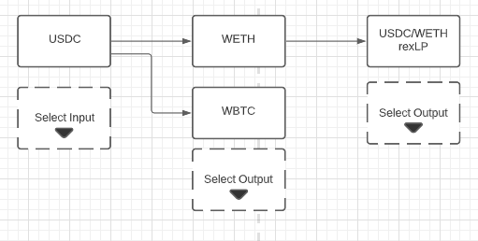

Comments:

* This kind of view is powerful because it lets the user directly view the networking of their investment cashflows and makes customization of their strategy super straightforward and digestible. Not to mention this would be unlike any DeFi UI out there. Game changer.
* This is really exciting 😤 Thanks Mihir for suggesting drop downs and getting me thinking about this